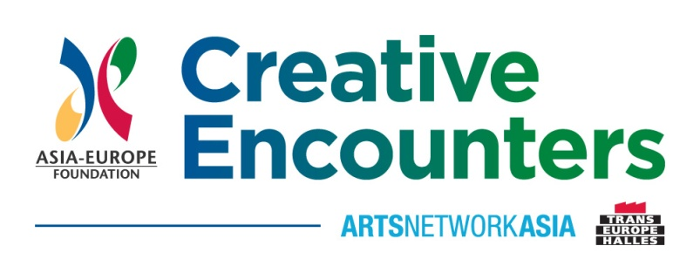

Title: TIES THAT BIND
Date/s: 29 April 2014 - 3 May 2014 (Phase 1: workshop and panels);
Venue/s: Udine, Italy

Date/s: 29 April 2014 - 3 May 2014 (Phase 2: workshop and panels);
Venue/s: Pusan, Korea

This project is supported by the programme Creative Encounters: Cultural Partnerships between Asia and Europe (3rd edition), promoted by the Asia-Europe Foundation (ASEF) and Arts Network Asia (ANA), in collaboration with Trans Europe Halles (TEH).

TOPICS AND ACTIVITIES COVERED

TIES THAT BIND brought together film producers with potential European-Asian co-production projects for a 5 day workshop in Udine. The schedule consisted of daily group work sessions, plenary sessions and individual meetings with a mixed team of Asian and European tutors/industry experts and decision makers. All participants went through an intense learning process centred on the projects but also acquired an in depth awareness of the audiovisual markets, including financing, sales, distribution and exhibition, co-production modalities and working methods and practices in Asia and Europe.
There are already several important existing connections between Europe and Asia but since they are two completely different markets, with different financing schemes, legal frameworks and working practices, film producers from both continents need a platform where they can acquire knowledge of both audiovisual industries. The primary goal of TIES THAT BIND is to bring producers into a close working relationship and to build for the medium and long term to the benefit of both continents. The workshop was attended by 22 selected producers and industry experts from 15 different ASEM countries (Belgium, China, France, Germany, Hong Kong, Italy, Japan, Malaysia, The Netherlands, Philippines, Poland, Singapore, Slovenia, South Korea, UK). The plenary session in cooperation with the festival was attended by 80 people.
TIES THAT BIND is organised by the FVG Audiovisual Fund (Italy), EAVE (Luxembourg), Far East Film Festival (Italy), Busan International Film Festival/Asian Film Market (South Korea). The workshop is supported by the Asia-Europe Foundation, Arts Network Asia, Trans Europe Halles and Creative Europe.

RESULTS OF THE PROJECT

The most important outputs are highly developed scripts and film projects coming out of the workshop. As a more immediate output, a website with information on the programme has been produced. We also published a catalogue with the projects that will be distributed worldwide.
For the medium to long term each producer will be in a stronger position to operate successfully in both continents. After TTB several participants are invited to other markets. We are planning to organize a gathering of all former participants in Cannes, to introduce the new participants and maintain their network with our decision makers.

LESSONS LEARNT

The biggest challenge was to find enough qualified producers in Asia and Europe, open to new markets outside their familiar but saturated markets. We faced this by a very pro-active process of promotion and scouting of potential applicants. Another crucial problem is the potential of high costs of an international programme in itself and for the participating producers linked to intercontinental flights. We are taking particular care of this by optimizing the synergies with the partners, by having long working days to take full advantage of the events and by offering several travel scholarships.
Both the organisation and the conduct of the workshop went very well and the cooperation between the partners was extremely professional and pleasant. One of the most successful ingredients of the workshop is to create a friendly and trusting environment for the participants to work, develop their projects, exchange knowledge and best practices and to network.

Annex:
List of facilitators, participants, organisers and partners

