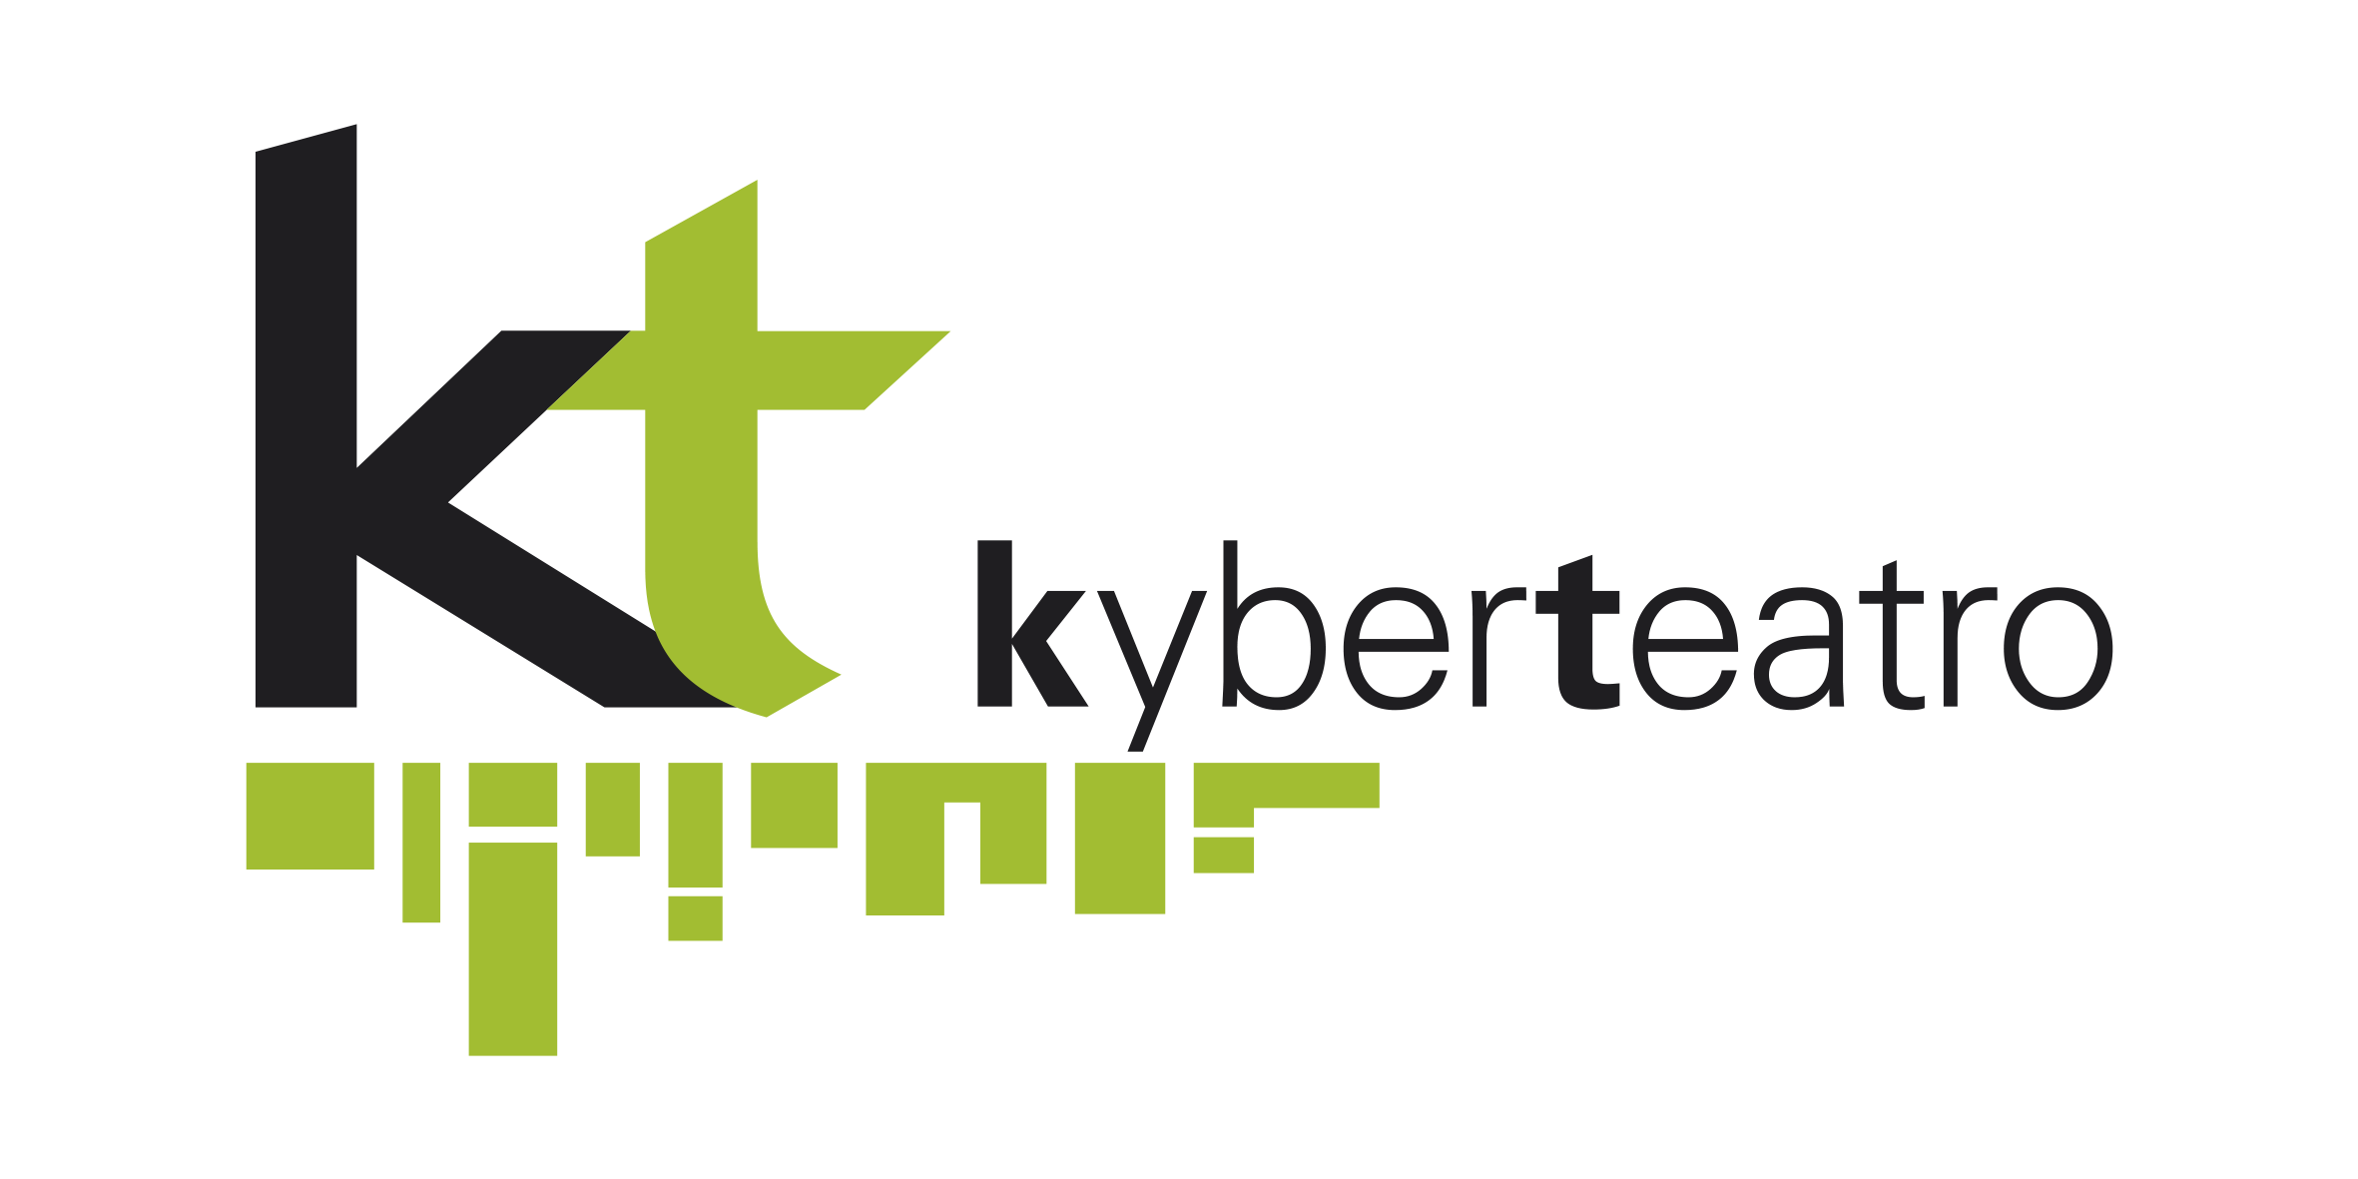

Festival Internazionale di Teatro Arte e Nuove Tecnologie

LE MERAVIGLIE DEL POSSIBILE
4th edition

Call for artists

On December 2017, Kyber Teatro organises in Cagliari (Italy) the fourth edition of International Theatre, Art and New Technologies Festival
Le meraviglie del Possibile.

LMDP Festival is the first of this kind in the whole Italy. It aim to promote the interrelation between artistic and technological languages.
The Kyber Teatro – spin off of L’Aquilone di Viviana theatre company, creator and manager of the Festival, addresses to Italian and International artists an Open Call to submit their projects about “Interaction between arts and technology”.

Who can attend
The participation is open to artists of every nationality, working individually or in a group.

Eligible projects

- Theatrical plays, performances.
- Installations that explore and realize the interaction between artwork, exhibition space and observers with the contribution of technology.

Application (deadline 21st September 2017)
The theme of the fourth edition of LMDP Festival is the interrelation between theatre, arts and new technology.
The application must contain:
• Artist's CV;
• Detailed description of the project (in PDF);
• Technical rider;
• Selection of max 5 photos;
• Link audio / video material (Vimeo or Youtube).
The result is going to be notified only to selected projects by the 1st September 2017.

Publication
Applying for the call, artists agree that the projects should be represented at the Festival. Selected artists must provide a short biography and an abstract of the project. They also agree that the material related to the project could be published on the Festival website and/or presented to the press for promotional purposes.

Archiving process
Artists authorise Kyber Teatro - L'aquilone di Viviana to present their work, to store the
material and make it accessible through the Festival's website. All rights to the artwork and images will remain to the artist. The Organization is also entitled to document the event in all its phases through audio recordings,
video or images.

Application materials must be sent to: info@kyberteatro.it

Kyber Teatro - L'Aquilone di Viviana Soc. Coop.
Via Newton 12, 09131 Cagliari
Tel: +39 0708607175 - Mob: + 39 3470484783
info@kyberteatro.it

